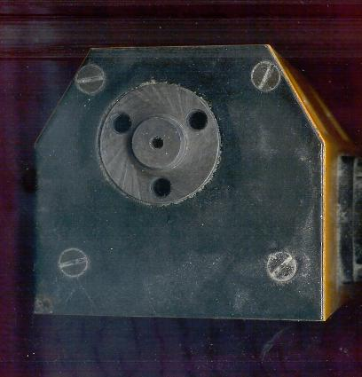
Overall Height is 75mm
Center height from bottom to top of “BOSS” is 56mm. “Boss is 15mm. (I have no way tio get an accurate centerline measurement. Subtracting ½ the boss center height is approx. 48.5mm
“BOSS” is 15mm (14.9)

Length from left to right of bottom is 80mm

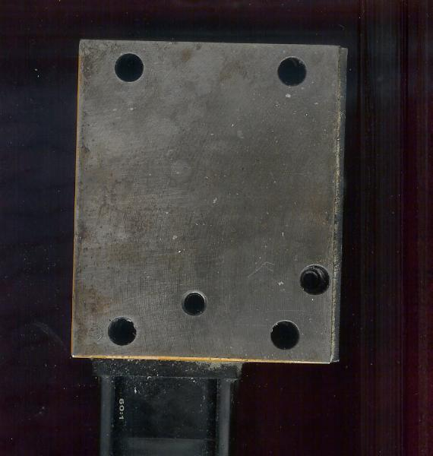
Width 66.2mm

Length 80mm

Mounting Holes 7mm diameter

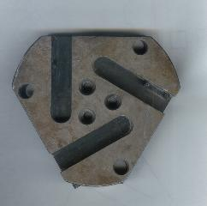
From outside radius to center is 60mm

Flat sides are 3 “inches”

Holes are 10mm.

“I suggest making this 3/16” larger on the side so you can bore holes for round tooling to ½” much cheaper than 10mm tooling!” As this built now thwere is no metal left if you bore these out, so they are to big for 3/8 and too small for ½” tooling
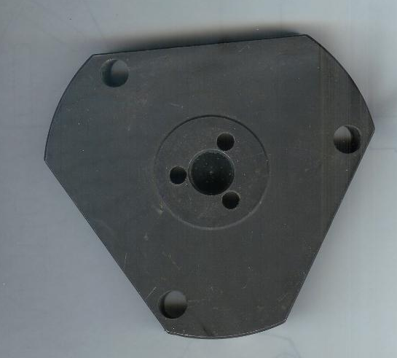
15mm

40mm circle for standoff

6.3mm

** 60mm to center of outside radius

I would add 3/16 material here so the holes can be bored to accept ½” tooling..

**

Note on my cross slide I milled away ¼” material on the left of the saddle,where tool rotates. This allows me to use tooling that is readily available, is indexable, cheap, AND it then will clear when turret makes its rotation. Before milling this away some of the tooling would catch, or the tool holder bottom would not clear. IF I inserted the tool holder for tip t clear I had no height adjustment. Finding the perfect tool holder was a long process. Making this clearance bigger opened up a lot of tooling options for off the shelf tooling. !/2” tooling!. Using Metric tooling almost doubles the cost of a tool holder. I will try to send a photo of my tooling set up.
IF you don’t make allowance for this clearance most tooling extends so far they “”catch”” or you have a limit on depth of cut for profiling. The saddle has plenty of material to mill away a ¼” and still be stable. Providing clearance for a VCGT (35 degree diamond) insert carbide tool. (you can find the geometry designations on Kennemetal or Rouse Arno website). After this small modification I can now set up the tool holder off the machine, and change inserts without ever taking out the holder or losing centerheight postion.

Here is my method of setting the turret up for accurate center height.

Put a piece of ground 10mm stock in the collet (chuck if you don’t have a collet holder) Try to get it dialed in so it is running TRUE in Headstock.
Jog tool turret to center line, with one of the 100mm tool holders indexed into work postion.
Leave the turret bolts loose.
ManuallyJog in Z until the round stock slips into the tool holder.
With the bolts lose this will bring the tool holder into center line for height.
Tighten the tool holder bolts on turret.
Jog off in Z
Change turret two stations so the next round hole is presented.
Jog in Z and the round bar should slip right into the hole.
Repeat for the last round tool holder of turret.
this will make all the “ROUND” tools on center line.
Then shim the square shank tools or mill some off the top as needed to get them to center height.
Now all your tools will be on center line.

